Assignment 6

# Error Bar

An error bar is a tool that can be applied on a number of graphs including scatterplot, bar chart and line chart. It can present an additional layer of detail on presented data as they indicate an estimation of error or uncertainty to give a general sense of how precise the measurement is. An error bar is usually used to display standard deviation, standard error or confidence intervals.

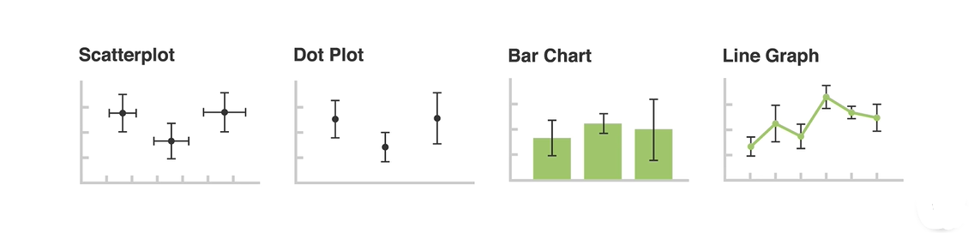

An error bar is drawn using capped lines that extend from the center of the plotted data or from the edge in the case of bar charts. The length of the error bar indicates the uncertainty of a data point where a short error bar indicates a reliable data point while a long error bar indicates an unreliable data point. The center of an error bar usually divides the error bar into two equal halves but should that center of the error bar be skewed meaning the upper and lower parts are not equal, this indicates that there is skewness in the data.

